Month Mania
When it's the end of January and we need to turn over a page of our calendar, the next page may look a bit like this:
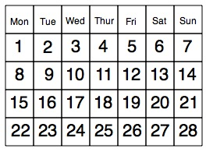
Of course, it probably has a good picture on the page as well, perhaps of a countryside scene, pop star or an animal.
If we ignore the edge squares which tell you what day of the week it is, then we have a rectangle with twenty eight squares in it like this:-

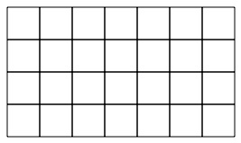

Well, how about going a bit wild and designing a new shape for these twenty eight squares in which the numbers follow on in some way that is not too difficult to follow?
For example, you could put the twenty eight squares into a triangle and decide to go in an up-and-down order like this:-
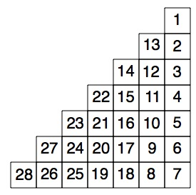
What other wonderful designs can you come up with?
You can then go further by looking at the way the numbers are arranged and see if you can spot any patterns. For example in the first usual way:-
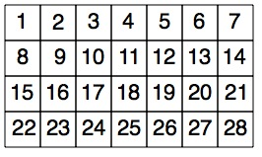
you may notice things like:
1. If you take any two by two square (like the one in at the top left-hand corner with 1, 2, 8 and 9 in it), then the opposite corners of that square add up to 10. Then, if you take the next two by two square along [with 3, 4, 10 and 11 in] then the opposite corners add up to 14 and so on.
2. Going down any column the numbers increase by 7.
Can you explain why the patterns occur?
Then ask "I wonder what would happen if ...?''

